

Lifting
The Region 3 Division 2&3 Regional Meet will be on

Friday, March 6th, 2026 at Arp High School, Arp TX

  - Begins at 8:30 AM in the Gym (Map attached)

Platforms
  - There will be 6 platforms, and 2 flights.

Div 3 Platform 1 Platform 2 Platform 3
114,123 | 165,181 | 242,275
132,148 | 198,220 | 308,SHW
Div 2 Platform 4 Platform 5 Platform 6
114,123 | 165,181 | 242,275
132,148 | 198,220 | 308,SHW

Bring with you:
  - Eligibility Form - Signed by your Principal or Superintendent
  - Scholarship Application (Optional) For senior lifters who would like to be considered for a
$1,000 scholarship to help with college expenses.
  - Check for $35.00 per lifter payable to: Arp ISD Athletics*
*Your school becomes responsible for your lifter(s) entry fee at 4:00 p.m., Monday March 2nd. Please notify me on or before the deadline if your lifters can’t compete or you will be responsible for their entry fee.
*No payment is necessary for alternates.

Alternates
  - If you have lifters ranked in the top 20, bring them with you as there may be no-shows or lifters who do not make weight.

Weigh In
  - Thursday, March 5th - early weigh in: 5:00 to 6:30 P.M. (Junior High Gym)
  - Friday, March 6th - weigh in: 6:00 A.M. to 7:30 AM.

Coaches / Judges Meeting
  - 8:00

Admission
  - $5.00 (cash only)

T-shirts

  - Will be available

Supper
  - There will be a lunch served for the coaches.
  - Meals for the athletes: Please notify me by e-mail at wess@arpisd.org how many meals you will need.The cost will be $9.00 each. Make checks for athlete’s
meals payable to Arp ISD Athletics. Entry and meal checks can be on one check.

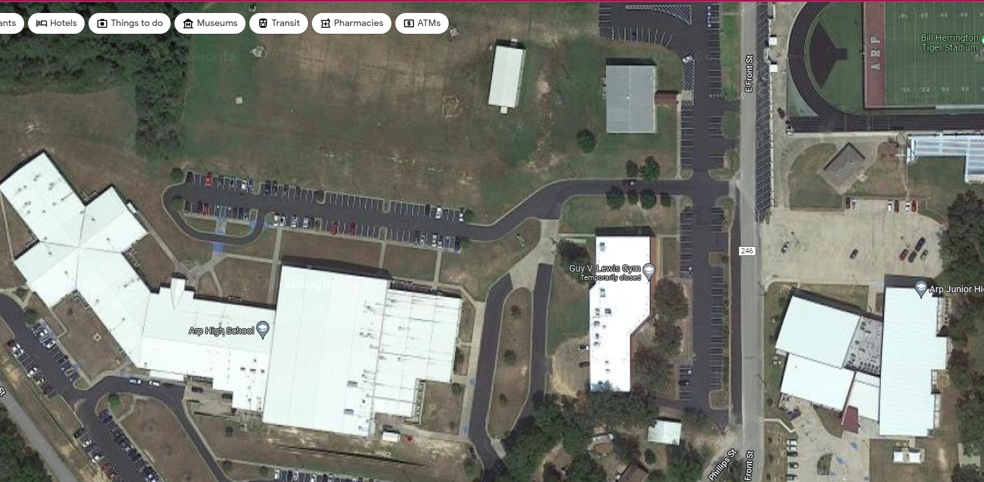

.
Gym Entrance
High School Gym
Early Weigh –In Thursday
Jr High Gym
Bus/Van Parking

